Design patterns help in addressing the recurring issues in software design and provide a shared vocabulary for developers to communicate and collaborate effectively. They have been documented and refined over time by experienced developers and software architects.
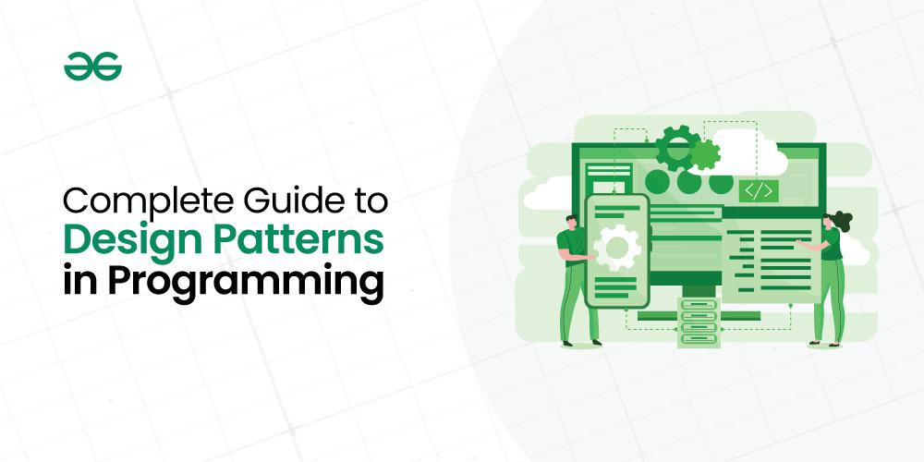
Complete Guide to Design Patterns in Programming
Important Topics for Guide to Design Patterns
- What are Design Patterns?
- Types of Design Patterns
- Use cases of Design Patterns
- Applications of Design Patterns
- When to avoid the use of Design Patterns ?
- How to learn Design Patterns?

1. What are Design Patterns?
Design patterns are basically defined as reusable solutions to the common problems that arise during software design and development. They are general templates or best practices that guide developers in creating well-structured, maintainable, and efficient code.

2. Types of Design Patterns
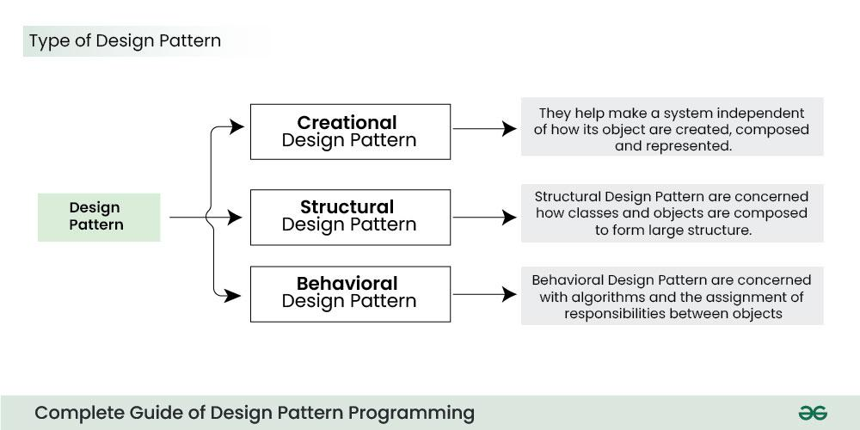
Types of Design Patterns
Basically, there are several types of design patterns that are commonly used in software development. These patterns can be categorized into three main groups:

1. Creational Design Patterns
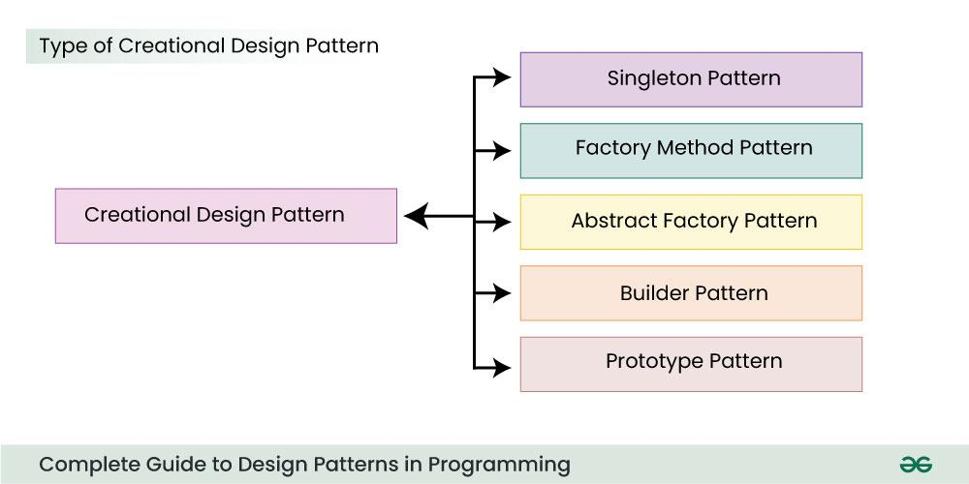
Types of Creational Design Patterns
- Singleton Pattern
  - The Singleton method or Singleton Design pattern is one of the simplest design patterns. It ensures a class only has one instance, and provides a global point of access to it.
- Factory Method Pattern
  - The Factory Method pattern is used to create objects without specifying the exact class of object that will be created. This pattern is useful when you need to decouple the creation of an object from its implementation.
- Abstract Factory Pattern
  - Abstract Factory pattern is almost similar to Factory Pattern and is considered as another layer of abstraction over factory pattern. Abstract Factory patterns work around a super-factory which creates other factories.
- Builder Pattern
  - Builder pattern aims to “Separate the construction of a complex object from its representation so that the same construction process can create different representations.” It is used to construct a complex object step by step and the final step will return the object.
- Prototype Pattern
  - Prototype allows us to hide the complexity of making new instances from the client.
  - The concept is to copy an existing object rather than creating a new instance from scratch, something that may include costly operations. The existing object acts as a prototype and contains the state of the object.

2. Structural Design Patterns
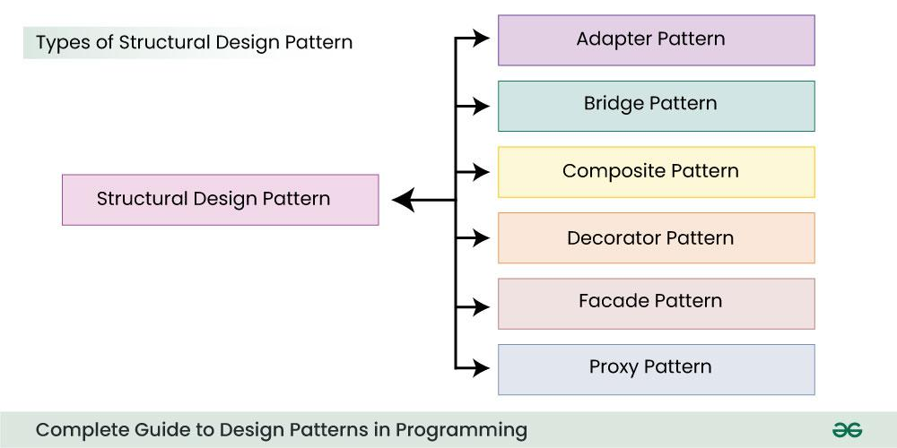
Types of Structural Design Pattern
- Adapter Pattern
  - The adapter pattern convert the interface of a class into another interface clients expect. Adapter lets classes work together that couldn’t otherwise because of incompatible interfaces
- Bridge Pattern
  - The bridge pattern allows the Abstraction and the Implementation to be developed independently and the client code can access only the Abstraction part without being concerned about the Implementation part
- Composite Pattern
  - Composite pattern is a partitioning design pattern and describes a group of objects that is treated the same way as a single instance of the same type of object. The intent of a composite is to “compose” objects into tree structures to represent part-whole hierarchies.
- Decorator Pattern
  - It allows us to dynamically add functionality and behavior to an object without affecting the behavior of other existing objects within the same class.
  - We use inheritance to extend the behavior of the class. This takes place at compile-time, and all the instances of that class get the extended behavior.
- Facade Pattern
  - Facade Method Design Pattern provides a unified interface to a set of interfaces in a subsystem. Facade defines a high-level interface that makes the subsystem easier to use.
- Proxy Pattern
  - Proxy means ‘in place of’, representing’ or ‘in place of’ or ‘on behalf of’ are literal meanings of proxy and that directly explains Proxy Design Pattern.
  - Proxies are also called surrogates, handles, and wrappers. They are closely related in structure, but not purpose, to Adapters and Decorators.
- Flyweight Pattern
  - This pattern provides ways to decrease object count thus improving application required objects structure. Flyweight pattern is used when we need to create a large number of similar objects

3. Behavioral Design Patterns
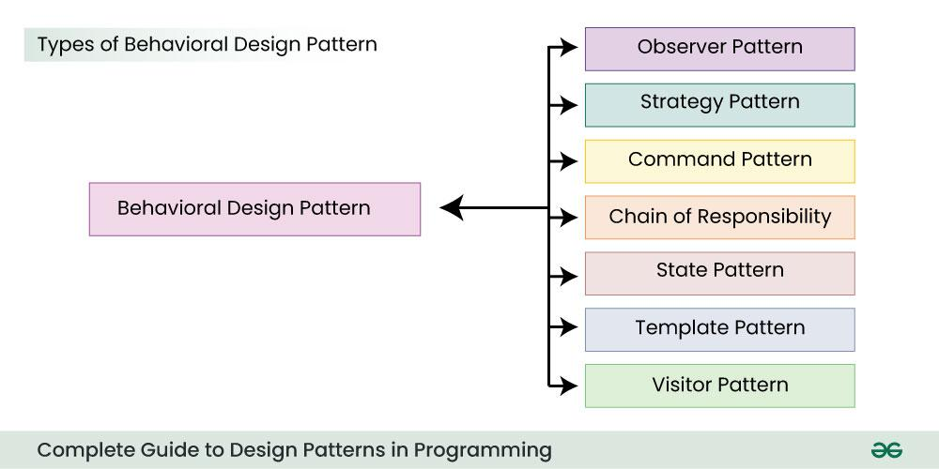
Types of Behavioral Design Pattern
- Observer Pattern
  - It defines a one-to-many dependency between objects, so that when one object (the subject) changes its state, all its dependents (observers) are notified and updated automatically.
- Strategy Pattern
  - that allows the behavior of an object to be selected at runtime. It is one of the Gang of Four (GoF) design patterns, which are widely used in object-oriented programming.
  - The Strategy pattern is based on the idea of encapsulating a family of algorithms into separate classes that implement a common interface.
- Command Pattern
  - The Command Pattern is a behavioral design pattern that turns a request into a stand-alone object, containing all the information about the request. This object can be passed around, stored, and executed at a later time
- Chain of Responsibility Pattern
  - Chain of responsibility pattern is used to achieve loose coupling in software design where a request from the client is passed to a chain of objects to process them.
  - Later, the object in the chain will decide themselves who will be processing the request and whether the request is required to be sent to the next object in the chain or not.
- State Pattern
  - A state design pattern is used when an Object changes its behavior based on its internal state. If we have to change the behavior of an object based on its state, we can have a state variable in the Object and use the if-else condition block to perform different actions based on the state.
- Template Method Pattern
  - Template method design pattern is to define an algorithm as a skeleton of operations and leave the details to be implemented by the child classes. The overall structure and sequence of the algorithm are preserved by the parent class.
- Visitor Pattern
  - It is used when we have to perform an operation on a group of similar kind of Objects. With the help of visitor pattern, we can move the operational logic from the objects to another class.
- Interpreter Pattern
  - Interpreter pattern is used to defines a grammatical representation for a language and provides an interpreter to deal with this grammar.
- Mediator Pattern
  - It enables decoupling of objects by introducing a layer in between so that the interaction between objects happen via the layer.
- Memento Pattern
  - It is used to restore state of an object to a previous state. As your application is progressing, you may want to save checkpoints in your application and restore back to those checkpoints later.
  - Intent of Memento Design pattern is without violating encapsulation, capture and externalize an object’s internal state so that the object can be restored to this state later.

3. Use cases of Design Patterns
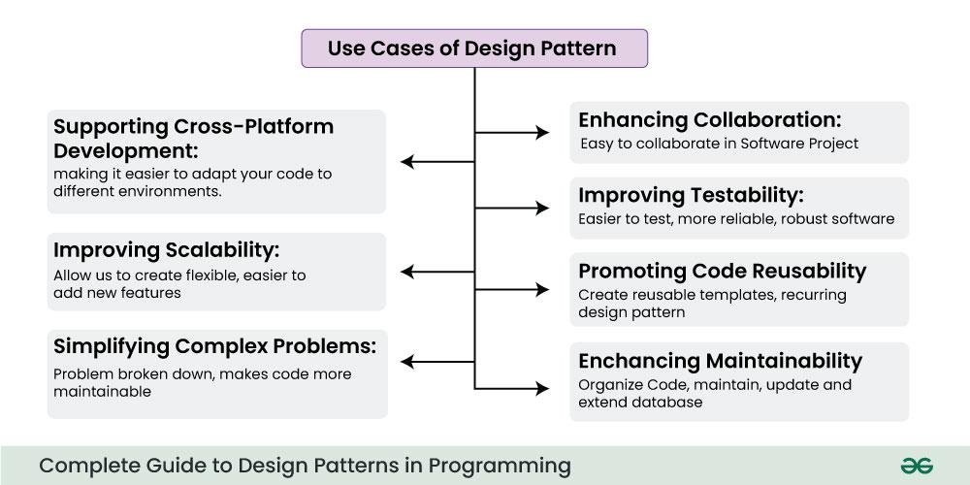
Use Cases of Design Pattern
Design patterns are a valuable tool in software development, and they offer various benefits and uses, some of them are explained below :
- Enhancing Maintainability:
  - Design patterns help organize code in a structured and consistent way. This makes it easier to maintain, update, and extend the codebase. Developers familiar with the patterns can quickly understand and work on the code.
- Promoting Code Reusability:
  - Design patterns encapsulate solutions to recurring design problems. By using these patterns, we can create reusable templates for solving specific problems in different parts of your application.
- Simplifying Complex Problems:
  - Complex software problems can be broken down into smaller, more manageable components using design patterns. This simplifies development by addressing one problem at a time and, in turn, makes the code more maintainable.
- Improving Scalability:
  - Design patterns, particularly structural patterns, allow us to create a flexible and extensible architecture, making it easier to add new features or components.
- Improving Testability:
  - Code designed with patterns in mind is often more modular and easier to test. we can write unit tests for individual components or classes, leading to more reliable and robust software.
- Supporting Cross-Platform Development:
  - Design patterns are not tied to a specific programming language or platform. They are general guidelines that can be applied across different technologies, making it easier to adapt your code to different environments.
- Enhancing Collaboration:
  - Design patterns provide a common language and a shared understanding among team members. They enable developers to communicate effectively and collaborate on software projects by referring to well-known design solutions.

4. Applications of Design Patterns
Basically, design patterns should be used when they provide a clear and effective solution to a recurring problem in our software design. Here are some situations where we can use the design patterns.
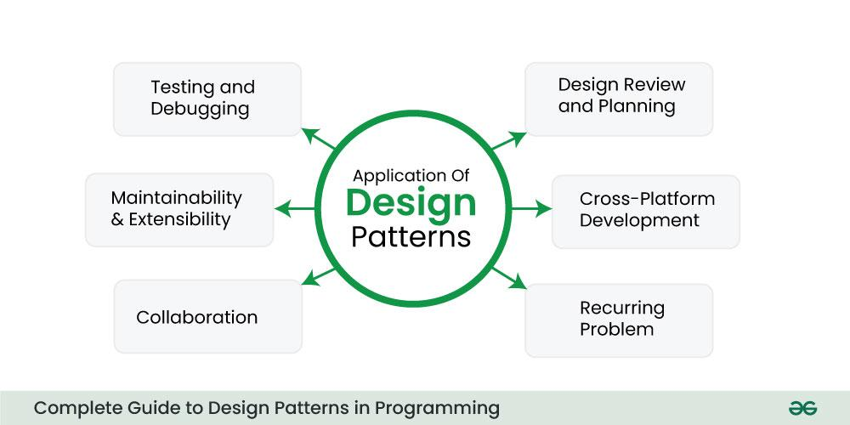
Application of Design Patterns
- Collaboration: Suppose if we are working in a team or on a project with multiple developers, so there design patterns can facilitate collaboration by providing a common language and shared understanding of how to address specific design challenges.
- Recurring Problem: Suppose if we encounter a design problem that we have seen in different forms in multiple projects or if it’s a well-known and documented problem in software development, it’s a good indicator that a design pattern might be useful.
- Maintainability and Extensibility: When we wants to create code that is easy to maintain, extend, and modify over time, design patterns can help by providing a structured approach to problem-solving.
- Cross-Platform Development: When we need to create code that works on different platforms or with various technologies, design patterns provide a platform-agnostic way to solve common problems.
- Testing and Debugging: Design patterns can make our code more modular and testable, leading to improved testing and debugging processes.
- Design Review and Planning: During the design and planning phase of a project, we can proactively consider the use of design patterns to solve anticipated design challenges.
It’s important to note that design patterns are not a one-size-fits-all solution. They should be used judiciously, and not all problems require the application of a design pattern. Always consider the specific context and requirements of your project when deciding whether to use a design pattern.

5. When to avoid the use of Design Patterns ?
There are situations where it’s best to avoid or be cautious about the use of design patterns . Here are some cases when we have to avoid the use of design patterns:
- Over-engineering: Don’t use design patterns just for the sake of using them. If a simpler and more straightforward solution can solve the problem effectively, choosing a design pattern can introduce unnecessary complexity.
- Lack of Relevance: If a design pattern doesn’t directly address the problem there we have try to solve, it’s better not to force-fit it into our code. Instead, consider other, more suitable solutions.
- Tight Deadlines: When we have tight project deadlines, spending extra time implementing design patterns might not be practical. Prioritize meeting project milestones over applying design patterns that might not be immediately necessary.
- Misapplication: Applying design patterns incorrectly can lead to code that is harder to understand and maintain. It’s crucial to understand the patterns thoroughly and apply them in the right context.
- Resource Constraints: In resource-constrained environments, such as embedded systems or performance-critical applications, design patterns might introduce overhead that affects system efficiency. In these cases, consider more lightweight solutions.
In general, the decision to use or avoid design patterns should be based on a careful consideration of the specific context, the problem we are trying to solve, and the skill level and familiarity of our team with design patterns.

6. How to learn Design Patterns?
Learning design patterns is a valuable skill for software developers and architects. Here are some key points where we can focus to learn Design Pattern.
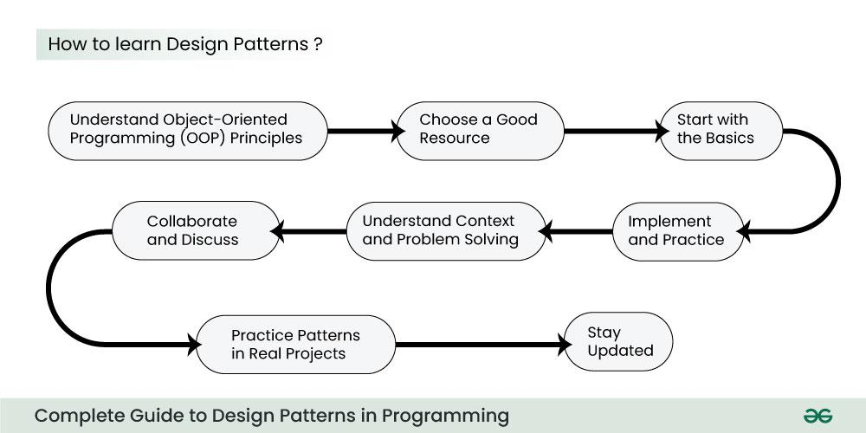
How to learn Design Patterns

6.1. Understand Object-Oriented Programming (OOP) Principles
Before diving into design patterns, ensure we have a solid understanding of OOP principles like encapsulation, inheritance, polymorphism, and abstraction, as design patterns often build upon these concepts.

6.2. Choose a Good Resource
Select a reputable book, online course, or tutorial that focuses on design patterns. Some well-regarded resources include “Design Patterns: Elements of Reusable Object-Oriented Software” by the Gang of Four (GoF), and online courses on platforms like Coursera, edX, or Pluralsight.

6.3. Start with the Basics
Begin with the fundamental design patterns. The Gang of Four book, for instance, covers 23 classic design patterns categorized into creational, structural, and behavioral patterns. Start with creational patterns like Singleton, Factory Method, and Abstract Factory.

6.4. Implement and Practice
Don’t just read about design patterns; implement them in our own code. Create small projects or code examples to apply the patterns that we learn. Practical experience is crucial for understanding how and when to use them.

6.5. Understand Context and Problem Solving
Focus on understanding the problem context that each design pattern addresses. Why was the pattern created, and in what situations is it most useful? Recognize the problems that each pattern aims to solve.

6.6. Collaborate and Discuss
Join programming forums, communities, or meetups where you can discuss design patterns with fellow developers. Peer discussions can provide different perspectives and insights.

6.7. Practice Patterns in Real Projects
Apply design patterns in real-world projects whenever we have the opportunity. This hands-on experience will help you gain a deeper understanding of their practical benefits and challenges.

6.8. Stay Updated
Keep up with the latest developments and trends in design patterns, as new patterns may emerge over time. The software development field is constantly evolving.

7. Conclusion
Always remember that the learning design patterns is an ongoing process, and it’s important to continuously practice and refine our knowledge. Over time, we will definately develop the ability to recognize when and how to apply design patterns effectively in our software design and development efforts.

